**LAB # 04**

**ARRAYS IN JAVA**

**OBJECTIVE**: To understand arrays and its memory allocation.

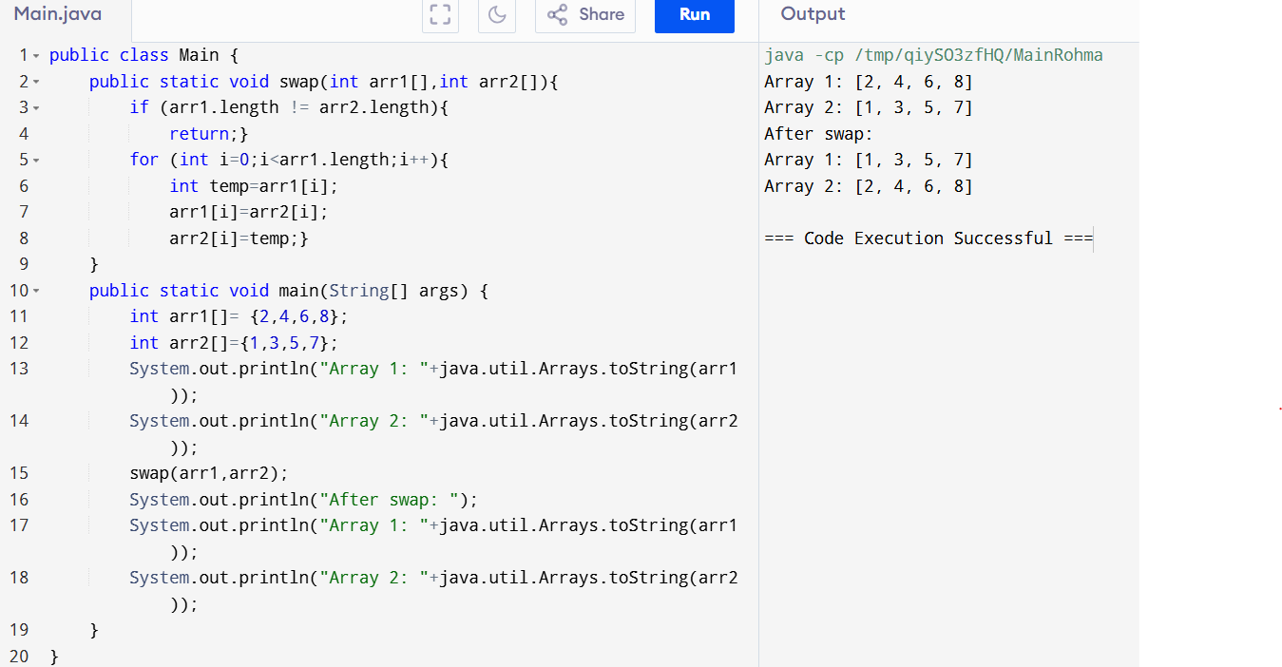**Lab Task 1:**

**Lab Task 2:**

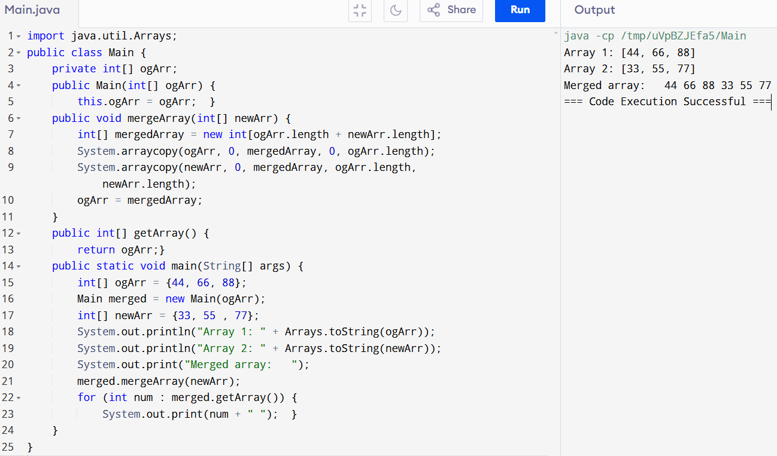

Lab Task 3:

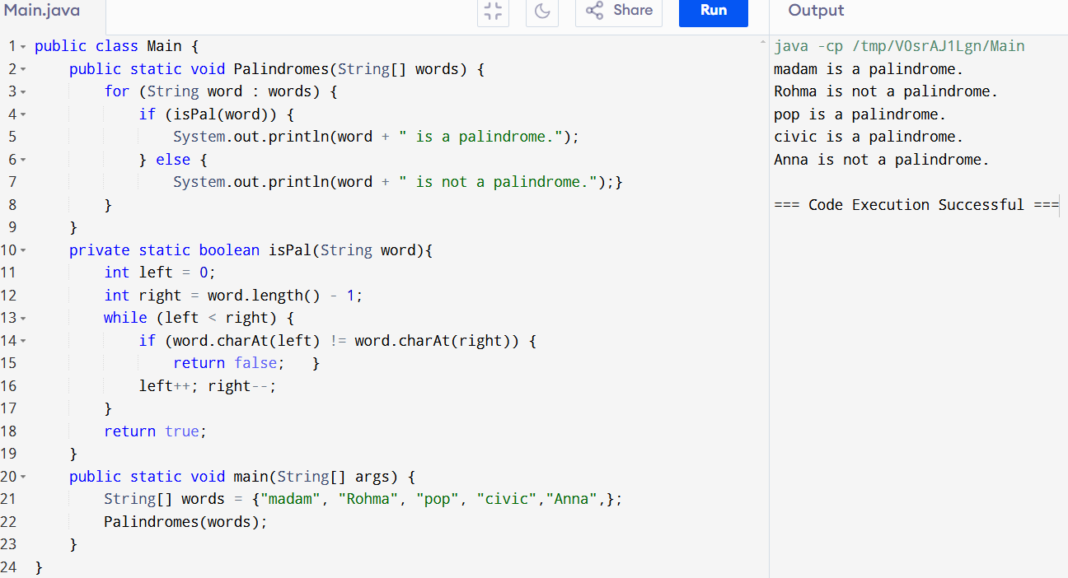

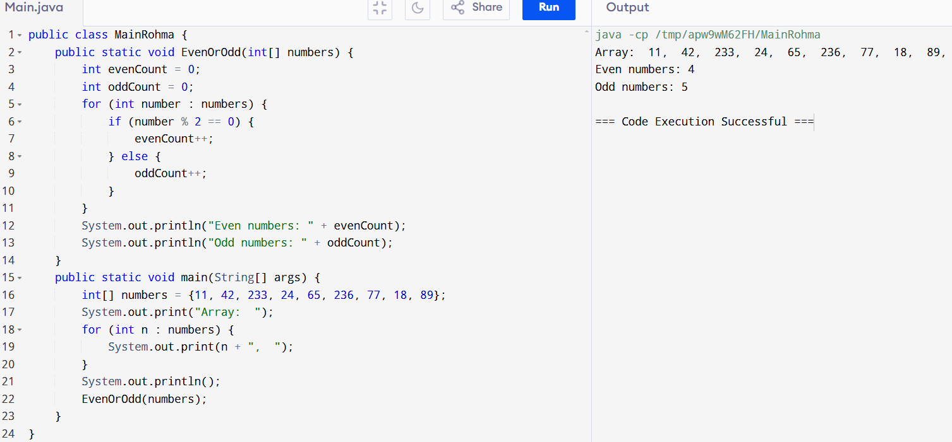Lab Task 4:

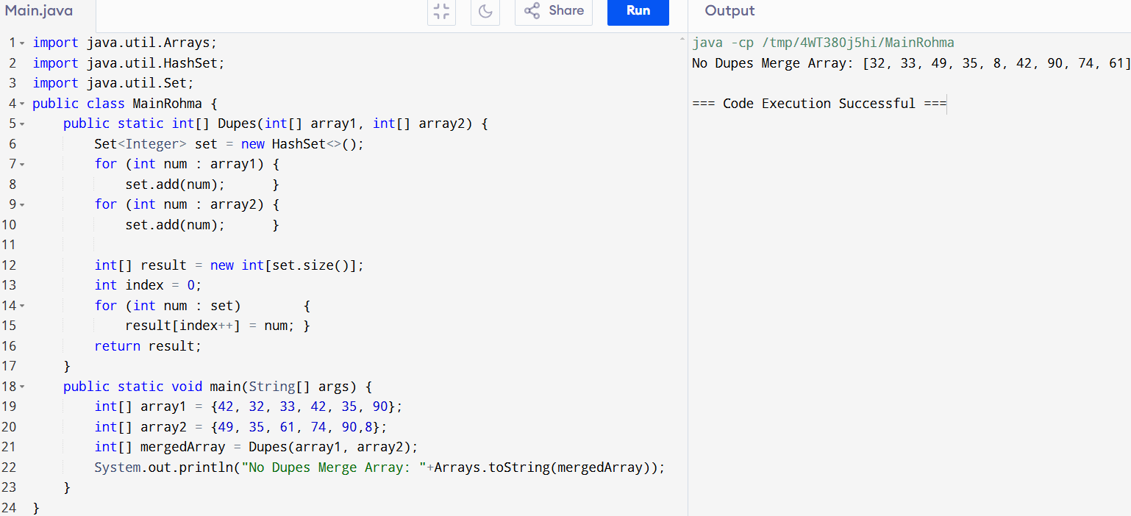Lab Task 5:

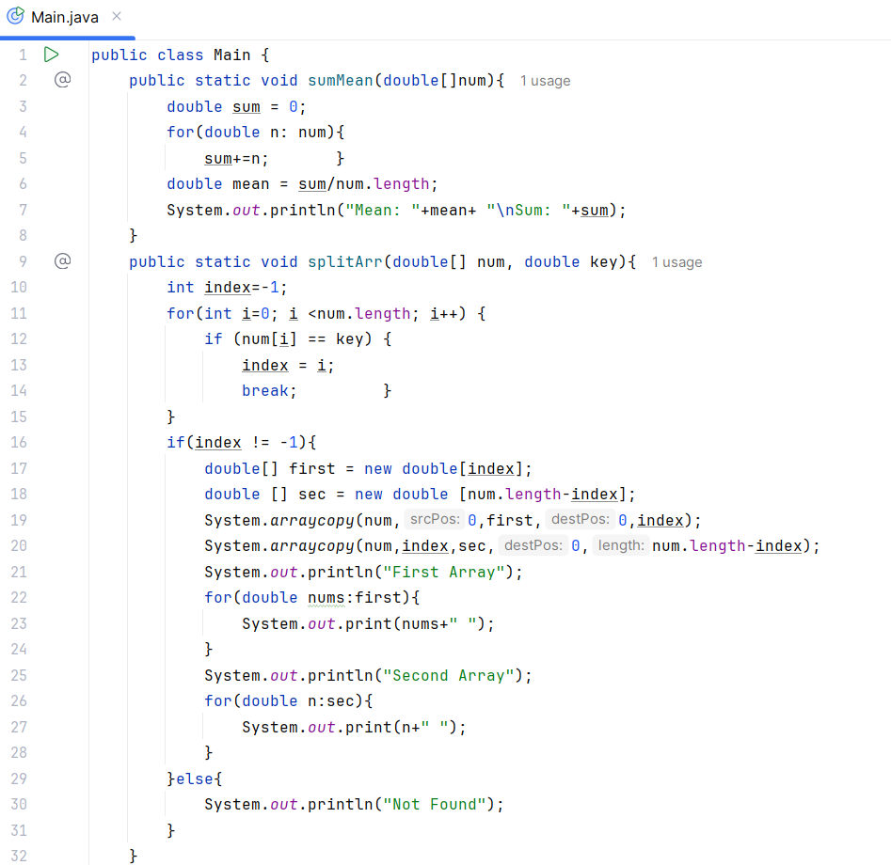Home Task 1 and 2:

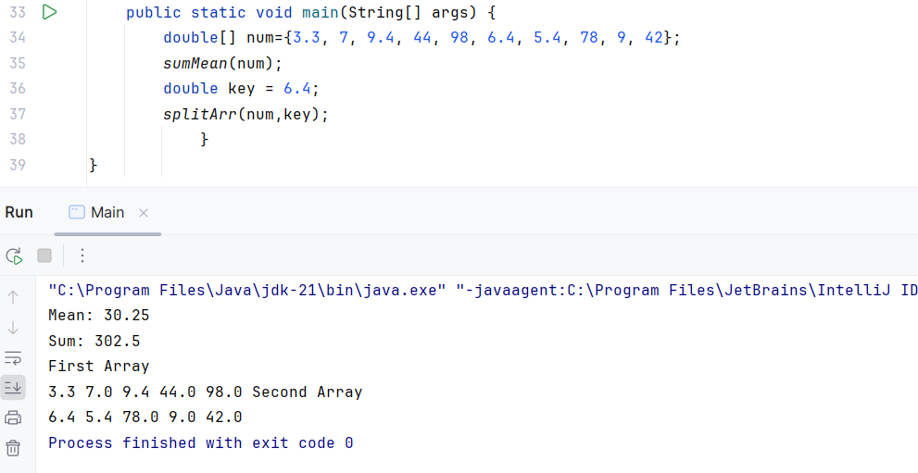

**Explanation of Memory Management**

* **Array Allocation:** Numbers is an array of size 7, each element occupying memory based on the double data type (typically 8 bytes per element).
* **Temporary Variables:** sum, mean, and index are stored on the stack for the sumMean and splitArr methods.
* **Array Splitting:** If the key is found, first and sec arrays are created dynamically based on the split point. System.arraycopy is used to copy elements, which is memory-efficient for this operation.
* **Garbage Collection**: After the method completes, all local variables go out of scope and become eligible for garbage collection, freeing up memory for further tasks.

Home Task 3:

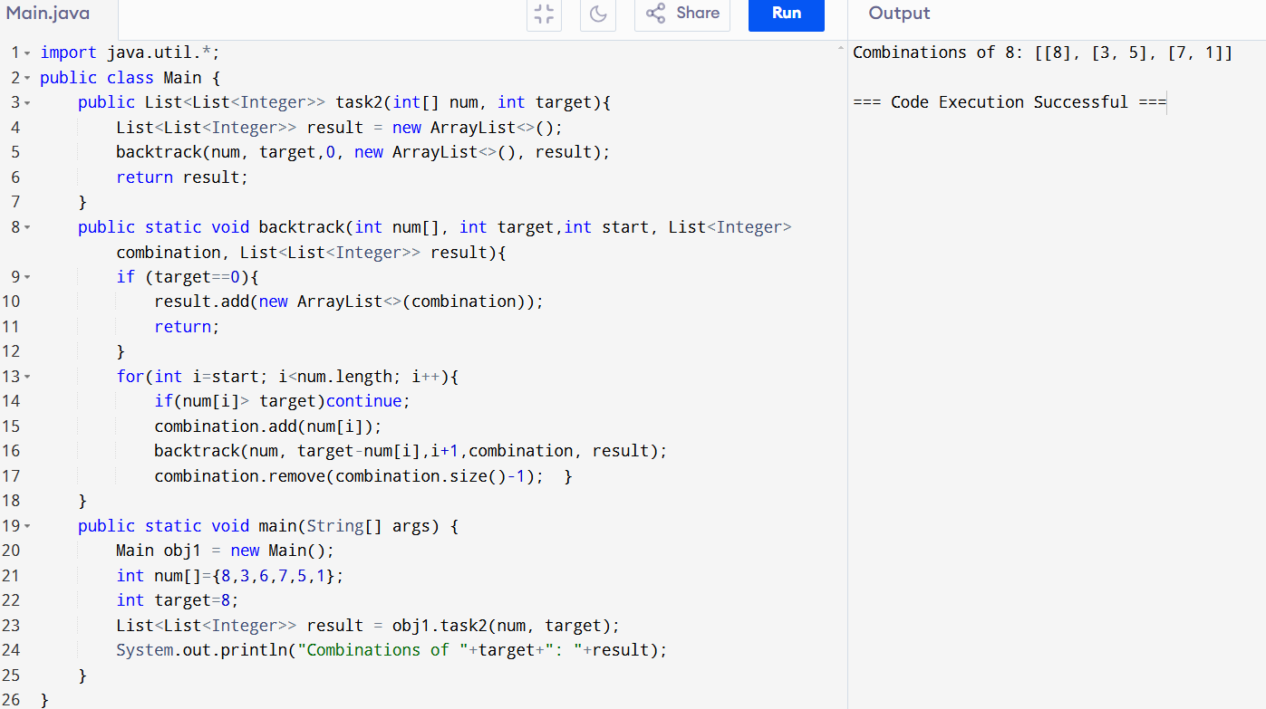

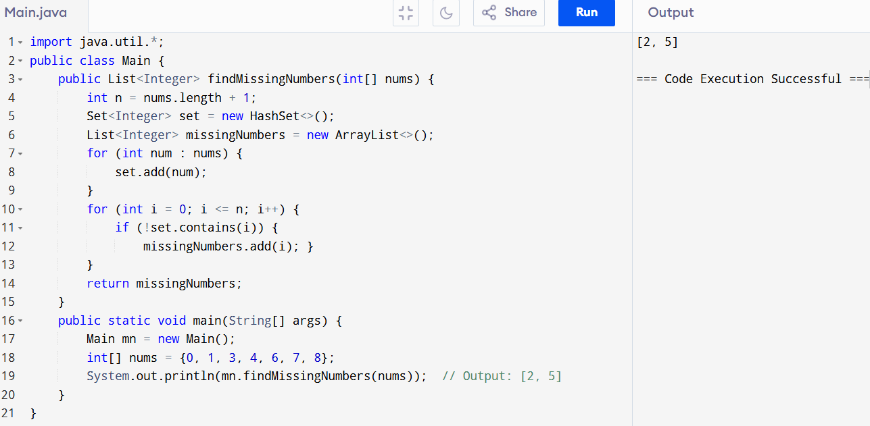Home Task 4:

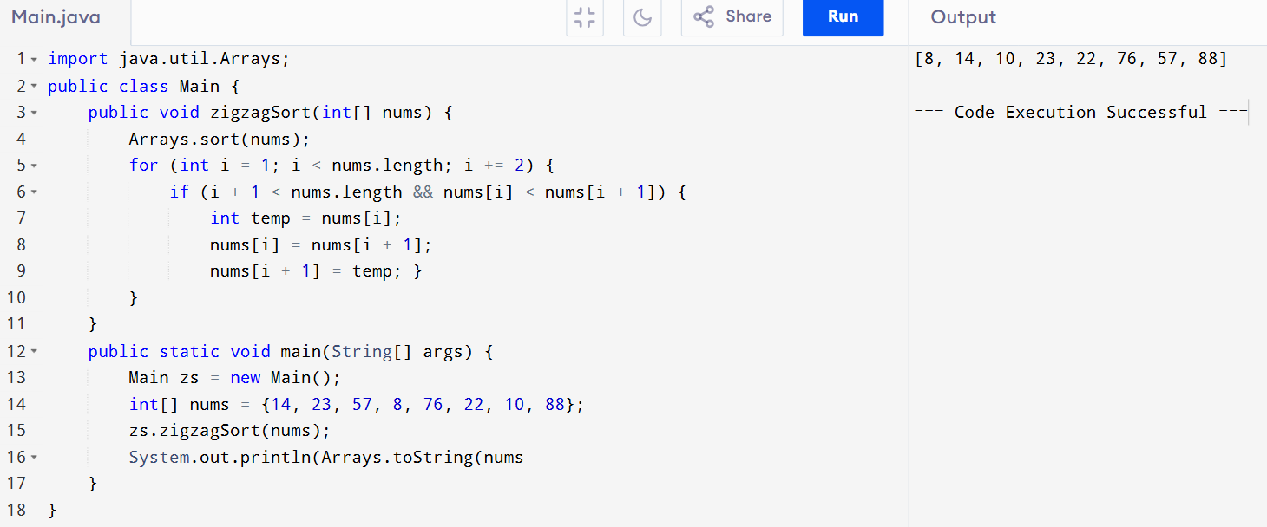Home Task 5: